MENTAL HEALTH WEBSITE

**UCS503 Software Engineering Project Report Mid-Semester Evaluation**

**Submitted by:**

## (102016064)Abhimanyu Atri

## (102016065)Smilee Aggarwal

## (102016069)Sudhang Mahajan

**BE Second Year, COSE**

**Group No: 2CS11**

**Submitted to: Dr. Ashish**



**Computer Science and Engineering Department**

**TIET, Patiala**

**TABLE OF CONTENTS**

**S.No.** **Assignment** **Page No.**

## 1. Project Selection Phase

1.1 Software Bid

1.2 Project Overview SRS

## 2. Analysis Phase

2.1 Use Cases

2.1.1 Use-Case Diagrams

2.1.2 Use Case Templates

2.2 Activity Diagram Diagrams

2.3 Data Flow Diagrams (DFDs)

2.3.1 DFD Level 0

2.3.2 DFD Level 1

## 3. Design Phase

3.1 Class Diagram

3.2 Sequence Diagram

3.3 Collaboration Diagram

3.4 Database Design: ER Diagram

3.5 State Chart Diagrams

## 4. Implementation

4.1 Component Diagrams

4.2 Deployment Diagrams

4.3 Screenshots

## 5. Testing

5.1 Test Plan

5.2 Test Cases

5.3 Test Reports

1. **Project Selection Phase**

**1.1 Software Bid/ Project Teams**

**UCS 503- Software Engineering Lab**

Group: 2CS11 Dated: 19-5-2022

**Team Name: ROG**

**Team ID (will be assigned by Instructor): 02**

Please enter the names of your Preferred Team Members.

* You are required to form **a three to four person** teams
* Choose your team members wisely. You will not be allowed to change teams.

|  |  |  |  |
| --- | --- | --- | --- |
| Name | Roll No | Project Experience | Programming Language used |
| Abhimanyu Atri | 102016064 | NIL | NIL |
| Smilee Aggarwal | 102016065 | NIL | NIL |
| Sudhang Mahajan | 102106069 | NIL | NIL |
|  |  |  |  |

**Programming Language / Environment Experience**

List the languages you are most comfortable developing in, **as a team**, in your order of preference. Many of the projects involve Java or C/C++ programming.

1. JavaScript

2. Html

3. CSS

4. Bootstrap

5. React

6. ejs

7. node js

**Choices of Projects:**

Please select **4 projects** your team would like to work on, by order of preference: *[Write at-least one paragraph for each choice (motivation, reason for choice, feasibility analysis, etc.)]*

|  |  |
| --- | --- |
| First Choice | Mental Health website |
| Second Choice | cricket |
| Third Choice | Automated shop tracking system |
| Fourth Choice | nil |

**Additional Remarks/ Inputs**

Please tell us about any other factors that we should take into consideration (e.g., if you really would like to work on a project for some particularly convincing reason).

………………………………………………………………………………………………

………………………………………………………………………………………………

………………………………………………………………………………………………

**1.2 Project Overview**

**PURPOSE OF THIS DOCUMENT:**

To define the purpose of our product, what we are building, individual requirements and proper delivery of the approval an SRS is made. The software requirements specification (SRS) is a document that describes what the software will do and how it will be expected to perform. It also describes the functionality the product needs to fulfil all stakeholders (business, users) needs.

**PURPOSE OF THIS PROJECT:**

The web app is made in consideration to the people who are suffering from common but threatening mental health issues. During the current pandemic many lives were destroyed due to mental health issues rather than the virus itself.

The Goal of this project is to develop a system that deals with day-to-day mental health issues like stress, anxiety, depression et al and spread awareness about the same. The software will provide with some relaxing activities while the main task is to develop a system that connects the someone suffering from mental health issues to a experienced and verified expert, and form a community where people can express their difficulties freely.

**SCOPE OF THIS PROJECT:**

In this system it will ensure people to get an expert advice from the people who are experienced and are certified to give advice to others. This platform could be utilized by the Doctors currently working in that hospital, as well as NGO people who would like to contribute their part.

The software will be showing following functionalities:

1. A Questionnaire to determine mental health status: There will be a basic questionnaire of 10-15 mins which will be determining ones mental health status by using certain algos in the backend to predict through those questions.

1. Spreading awareness about the mental health issues: It will be showing some facts and stats about the common mental health issues. With some help line numbers and ways to identify one of the same.

1. Some relaxing activities : It will also provide some online games to calm and relax ones mind, with soothing music and easing video clips.

1. An open portal to post: There will be open communication channel where users can post any thought or experience of their own choice and can also read others and also can message under these posts all while maintaining their anonymity.

1. Secure personal chats: The user can connect to other user or the verified experts and can chat with them on a personal end to end channel. The chatting feature will be secure maintaining privacy but also will be secure of any abusive word or harming text.

Initially we plan to add these functionalities for the current project for small number of users.

In the future we aim widen its scope to a larger audience and hosting it on a bigger platform and also to add more to these functionalities.

**INTRODUCTION:**

The introduction is divided into the following sections:

**Existing System**

**Proposed System**

The website would be mainly for the people dealing with minor mental health issues like stress, depression, anxiety, panic disorder, PTSD & and various others. The site would serve as a place to identify these issues and some possible ways to deal with them. Also the it would also aim to make a open community for these people where they can interact with others with same issues or had same issues in the past and share their experience all while maintaining their anonymity. There would also be connectivity to some experts and some informative material available on the site.

# ADVANTAGES

**-Advantages for the Users:**

* Exclusive mind relaxing games with positive quotes.

* Like minded people come together and share their thoughts, viewpoints and opinions on the ailment (which they may be suffering from or have suffered in the past or have seen a close one going through).

* People form NGOs can associate with our website and guide the patient to lead a better life.

* Our website is the junction point where the patient can seek advice from another person who have been through the same ailment.

**FUNCTIONAL REQUIREMENTS**

-**Login**: Both the user and admin will be able to login into the system via a valid email and password authentication.

* **USER PORTAL:**

**-SITE HOME:** There will the questionnaire to attempt. These all will be available to user without logging in to the system. **-Relaxing Zone:** In this section the user can play some relaxing games and also listen to some soothing music. This section is for escapism and to relax.

* **COMMUNITY:** This will be available after the login and here user can post any experience while maintaining anonymity but there would be a check for any harming text or toxicity and action would be taken immediately.

* **Test Record:** Under this section the user would be able to view all his previous test results that he had given in the site checking his progress. Also here would be record of any interaction of his with any expert through the site.

* **Profile:** In this activity, the user can edit some details about their profile and can also logout of the system.

**NON-FUNCTIONAL REQUIREMENTS**

* **SECURITY:** The admin and the user login would be kept separate so the admin would have the access over all the information in the database while the patient would have access only to his/her own information.

* **AVAILABILITY:** The servers and all its services will be available 24/7.

* **SCALABILITY:** Has been scaled to for small number of users with some experts for now.

## TECHSTACK USED

**Frontend:** HTML, CSS, Tailwindcss, Javascript

**Backend:** Node JS

**Database:** Mongo db

**DEPLOYMENT**

**Operating System:** Windows, MacOS, Linux.

## Hardware Specification

**Processor:** xxx

### RAM: xxx Hard Disk: xxx

## Analysis Phase

**UML DIAGRAMS**

* 1. **USE CASES**

RELAXING ACTIVITIES- Includes games and music, where people can come and release their stress.

AWARENESS AND STATISTICS- Normalising people about mental illness by providing relevant articles and quotes.

LOGIN-After login in the user gets to visit a lot of options of forming a community, joining one, connecting with experts, view someone’s post and add their own one. They can even comment under the posts. They also get to chat, or video experts to get expert advice.

CONTACT US- We would provide our mail id or telephone number for any sort of assistance.

ABOUT US- In this section we have complete information about the founders of the website, website’s authenticity and purpose behind starting it.

USER MANAGEMENT- admin looks into the functioning of the website and protects it from all kinds of threats.

SYSTEM MAINTENANCE- it includes bringing in new features and updates in the website to keep it up-to-date. Also, storing data into the database server.

**2.1.1 USE CASE DIAGRAM**

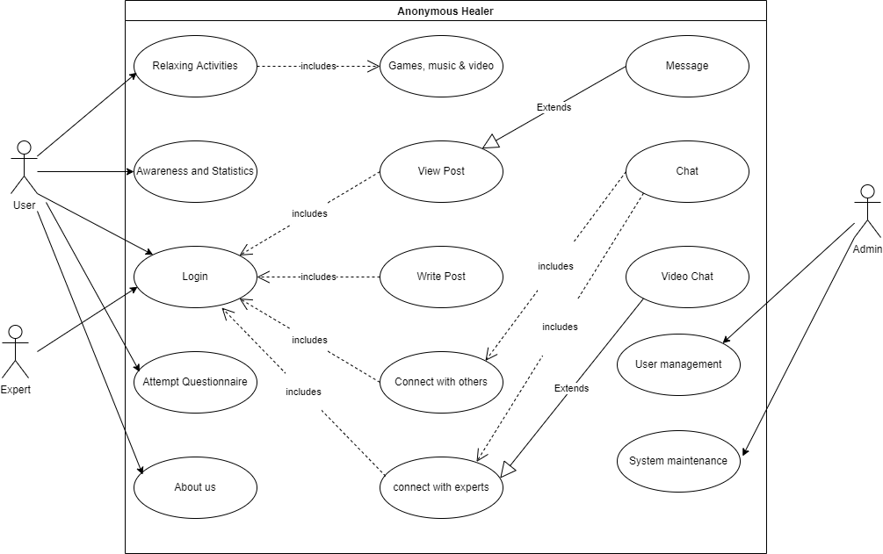

**2.1.2 USE CASE TEMPLATE**

|  |  |
| --- | --- |
| Pre-condition | NIL |
| Use Case | Relaxing Activities |
| Actors | User |
| Purpose | To release out stress and help in making the user better feel more calm |
| Overview |  |

|  |  |
| --- | --- |
| Pre-condition | NIL |
| Use Case | Awareness and Statistics |
| Actors | User |
| Purpose | To make the user feel homely and it is normal to have mental health issues. |
| Overview |  |

|  |  |
| --- | --- |
| Pre-condition | NIL |
| Use Case | Login |
| Actors | User, Expert |
| Purpose | This enables to check the user’s authenticity and open a door to various |
| Overview |  |

|  |  |
| --- | --- |
| Pre-condition | NIL |
| Use Case | Contact Us |
| Actors | User |
| Purpose | To address user query related to website |
| Overview |  |

|  |  |
| --- | --- |
| Pre-condition | NIL |
| Use Case | About us |
| Actors | User |
| Purpose | To provide information about the founder and the website’s authenticity. Thus assuring user that they are visiting a safe place. |
| Overview |  |

|  |  |
| --- | --- |
| Pre-condition | Actor must Login |
| Use Case | View post |
| Actors | User, Expert |
| Purpose | To make the user connect with several other people who have the same insecurities as they themselves by viewing other’s post, know what other’s thoughts say. |
| Overview |  |

|  |  |
| --- | --- |
| Pre-condition | Actor must Login |
| Use Case | Write post |
| Actors | User, Expert |
| Purpose | To get the user involved in the conversation of the community, we give them a chance to express their own thoughts in front of others. |
| Overview |  |

|  |  |
| --- | --- |
| Pre-condition | Actor must Login |
| Use Case | Connect with others |
| Actors | User, Expert |
| Purpose | If the user wishes to have a direct conversation with the another person from the community, they have the option to message them personally |
| Overview |  |

|  |  |
| --- | --- |
| Pre-condition | Actor must Login |
| Use Case | Connect with experts |
| Actors | User |
| Purpose | In order to get an expert advice, we need to ensure that the user have one-to-one conversation with the expert. For this we introduced chat and video calling features |
| Overview |  |

|  |  |
| --- | --- |
| Pre-condition | Actor must Login and Connect with experts or others |
| Use Case | Chat |
| Actors | User |
| Purpose | To acquire good advice from the expert, both must need to have a good amount of communication happening. |
| Overview |  |

|  |  |
| --- | --- |
| Pre-condition | Actor must Login |
| Use Case | Message |
| Actors | User |
| Purpose | To connect directly with another user. |
| Overview |  |

|  |  |
| --- | --- |
| Pre-condition | NIL |
| Use Case | User management |
| Actors | Admin |
| Purpose | To ensure the website is protected from all kinds of malware and hacking. |
| Overview |  |

|  |  |
| --- | --- |
| Pre-condition | NIL |
| Use Case | System management |
| Actors | Admin |
| Purpose | To keep the website update to date by adding trending features. Also, storing data into the database server. |
| Overview |  |

* 1. **Activity Diagram Diagrams**

**2.3 DFD**

### 2.3.1 0-LEVEL

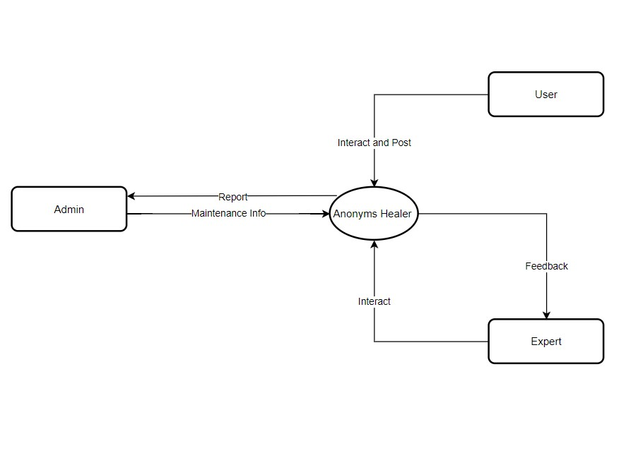

### Data Dictionary (for Data flow)

**Data flow name:** Report

**Data flow Description:**

givesworking report of website to admin

**Input Source:** Anonymous Healer

**Output Source:** Admin

### Data Dictionary (for Data flow)

**Data flow name:** Maintenance Info

**Data flow Description:**

Gives maintenance report to admin

**Input Source:** Anonymous Healer

**Output Source:** Admin

### Data Dictionary (for Data flow)

**Data flow name:** Interact

**Data flow Description**: user takes advice from the expert

**Input Source:** Anonymous Healer

**Output Source:** Expert

**Data Dictionary (for Process)**

**Process name:** Anonymous Healer

**Process Description:** It maintains the database server and other informations

**Inward flow(s):** Interact, Interact and Post, Maintenance info

**Outward flow(s):** Report, Feedback

**Process specification:**

### 2.3.2 1-LEVEL

**Data Dictionary (for Process)**

**Process name:** Questionnaire

**Process Description:** algorithm calculates the score

**Inward flow(s):** Attempt

**Outward flow(s):** Score

**Process specification:**

**Data Dictionary (for Process)**

**Process name:** Awareness and Info

**Process Description:** database server displays desired information

**Inward flow(s):** Search

**Outward flow(s):** Reply

**Process specification:**

**Data Dictionary (for Process)**

**Process name:** Relaxing Activities

**Process Description:** the user can listen to music or play games

**Inward flow(s):** Explore, request

**Outward flow(s):** Reply

**Process specification:**

**Data Dictionary (for Process)**

**Process name:** Maintenance

**Process Description:** update website with new features and displays information stored from database server

**Inward flow(s):** Request, Feedback

**Outward flow(s):** Report, Add component, Community Maintenance

**Process specification:**

**Data Dictionary (for Process)**

**Process name:** Login

**Process Description:** algorithm checks if the user account details matches with the one entered by the current user

**Inward flow(s):** Login, Response

**Outward flow(s):** Authentication, Interact

**Process specification:**

**Data Dictionary (for Process)**

**Process name:** Community Interaction

**Process Description:** post, like, commenting on each other’s post

**Inward flow(s):** Interact, Community Maintenance

**Outward flow(s):** Response, feedback

**Process specification:**

**Data Dictionary (for Data Store)**

**Data store name:** Games, music, etc

**Data store Description:** user can play games or play music that is stored in the database

**Data Dictionary (for Data flow)**

**Data flow name:** Attempt

**Data flow Description:** displays question on the screen

**Input Source:** User

**Output Source:** Questionnaire

**Data Dictionary (for Data flow)**

**Data flow name:** Score

**Data flow Description**: displays ailment type

**Input Source:** Questionnaire

**Output Source:** User

**Data Dictionary (for Data flow)**

**Data flow name:** Search

**Data flow Description:** checks in the database for the information which the user is asking

**Input Source:** User

**Output Source:** Awareness

**Data Dictionary (for Data flow)**

**Data flow name:** Reply

**Data flow Description:** gives desired information to the user

**Input Source:** Awareness

**Output Source:** User

**Data Dictionary (for Data flow)**

**Data flow name:** Login

**Data flow Description:** user enters login details

**Input Source:** User

**Output Source:** Login

**Data Dictionary (for Data flow)**

**Data flow name:** Authentication

**Data flow Description:** check whether the entered details matches with the information in the database

**Input Source:** Login

**Output Source:** User

**Data Dictionary (for Data flow)**

**Data flow name:** Login

**Data flow Description:** expert enters login details

**Input Source:** Expert

**Output Source:** Login

**Data Dictionary (for Data flow)**

**Data flow name:** Authentication

**Data flow Description:** to have only verified experts

**Input Source:** Login

**Output Source:** Expert

**Data Dictionary (for Data flow)**

**Data flow name:** Response

**Data flow Description:** user fills their login details

**Input Source:** Community Interaction

**Output Source:** Login

**Data Dictionary (for Data flow)**

**Data flow name:** Interact

**Data flow Description:** only after user logs in, they can interact with community

**Input Source:** Login

**Output Source:** Community Interaction

**Data Dictionary (for Data flow)**

**Data flow name:** Feedback

**Data flow Description:** feedback sent to community for maintenance

**Input Source:** Community Interaction

**Output Source:** Maintenance

**Data Dictionary (for Data flow)**

**Data flow name:** Community Maintenance

**Data flow Description:** keep a check that no abusive word is used

**Input Source:** Maintenance

**Output Source:** Community Interaction

**Data Dictionary (for Data flow)**

**Data flow name:** Request

**Data flow Description:** requesting for maintenance report

**Input Source: Admin**

**Output Source:** Maintenance

**Data Dictionary (for Data flow)**

**Data flow name:** Report

**Data flow Description:** protect website from malware

**Input Source:** Maintenance

**Output Source:** Admin

**Data Dictionary (for Data flow)**

**Data flow name:** Explore

**Data flow Description:** user can play games or listen to music

**Input Source:** User

**Output Source:** Relaxing Activities

**Data Dictionary (for Data flow)**

**Data flow name:** Add components

**Data flow Description:** add features according to new users

**Input Source:** Maintenance

**Output Source:** Games, Music, etc

## Design Phase

* 1. **Class Diagram**

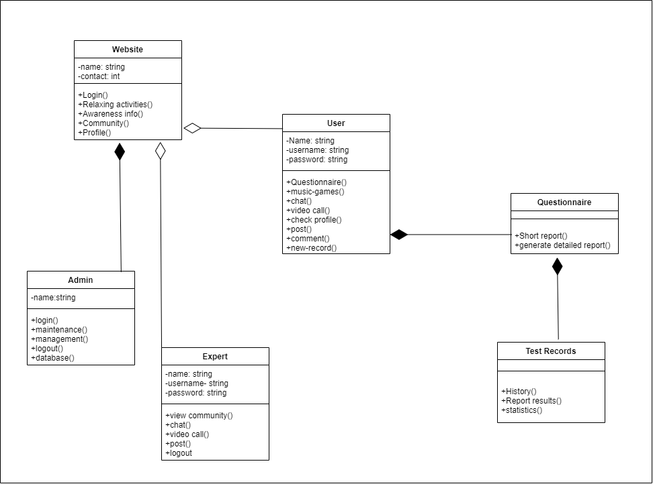

**3.2 Sequence Diagram**

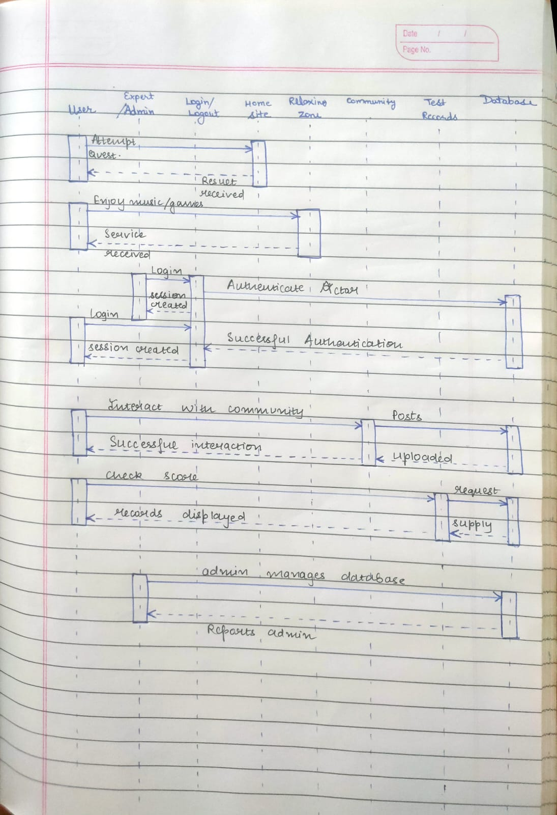

**3.3 Collaboration Diagram**

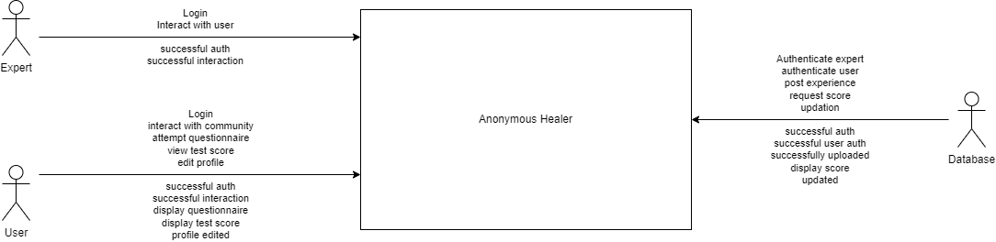

**3.4 Database Design: ER Diagram**

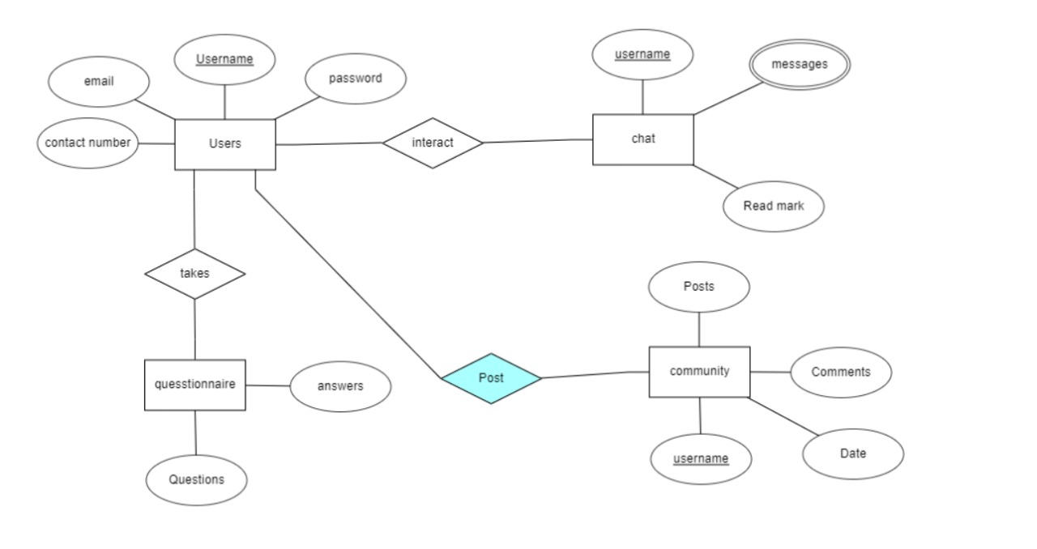

**3.5 State Chart Diagrams**

